Final Project

VaR and CVaR calculation using ARIMA model to predict stock prices

VaR calculation is very important in Risk Management. VaR will determine how much capital need to be kept in case of an unexpected loss.

In order to calculate the value at risk we have to obtain estimated prices, returns and profit and losses. In this project I use an ARIMA model to predict Apple stock prices. This model is a very popular method to model timeseries. I choose this model because the stock prices are correlated so the past observations are useful to predict future values.

In order to fit the model, we have to get the AR order(p), the degree of differencing(d), and the MA order(q). After that, we build the model and use cross validation in order to optimize the model. In this case after cross validation we obtain coefficients with p < 0.05 = significance level which means that all coefficients are statistically significant.

The ARIMA forecasting equation for a stationary time series is a linear equation.

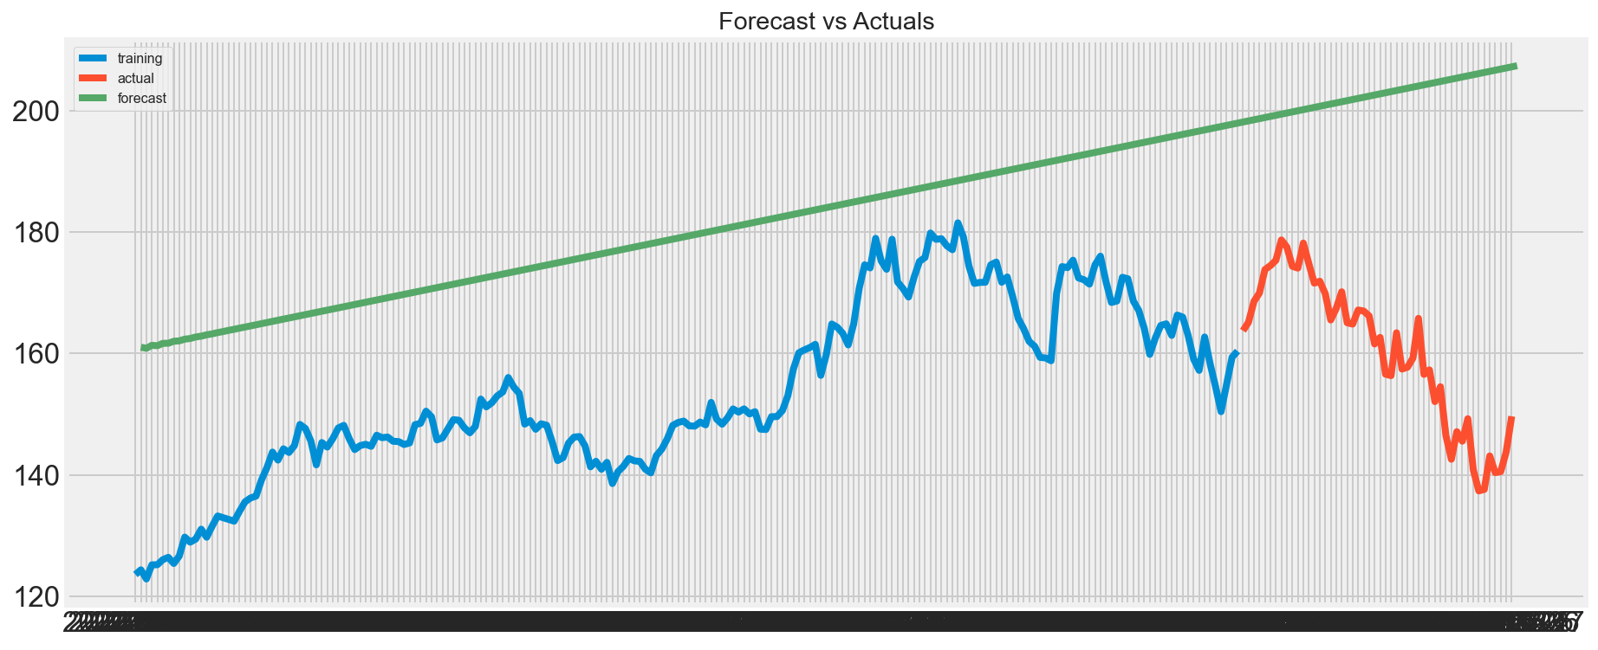

In conclusion, I think ARIMA it´s not the best model to predict stock values because forecasting is linear which means that future values won´t be able to have the same movements as real prices.